**Progress Report 2: Tree Parsing, Mutation & Long-term Goals**

The parser has been completed and can parse any expression with explicit parentheses inserted and (0-X) for negative numbers. This will act as the “DNA” of our symphony-generating expressions. The next stage is to implement a function which will mutate these trees probabilistically with sufficient degrees of freedom. This will consist of four types of mutations:

1. Change of Operator: Changes one random operator in the tree to another randomly selected one
2. Change of Variable: Each numerical leaf node is incremented (or decremented) with a randomly selected number from a normal distribution with a pre-set standard deviation.
3. Extension: Replaces one random leaf node with a randomly generated 3-node tree, making sure bit-shifts are not negative.
4. Trim: randomly deletes a three-node subtree and replaces it with “t” or a numerical value

Currently, I have developed the Change of Variable mutation and have already noticed high-degree of variance in musical output even when using a standard deviation of two (*See images bellow*). Some mutations have resulted in “dead-children” which consist of an array of zero values, I am currently working on a solution to this. Additionally, while the mutations are generated very quickly at the moment, conversion into an array can often take some time, one way to solve this in the future could be to lower the sampling rate and read-frequency.

After the mutations are fully developed, I will begin developing a discrimination strategy to select “winning children” from the various mutated arrays. Once this is done, it will act as the skeleton for what will go on to become a fully-functioning GAN algorithm. I can see two ways of going about discrimination, one would be MIR-focused, generating a musicality score based on features like onset detection, beat detection, and melody extraction. The other would be a neural network trained to detect whether a sound file belongs to a training data set or not (could be a dataset of EDM songs). The algorithm would assign a probability of the sound file belonging to the dataset and the generator’s goal would be to maximize this probability.

**PARENT**

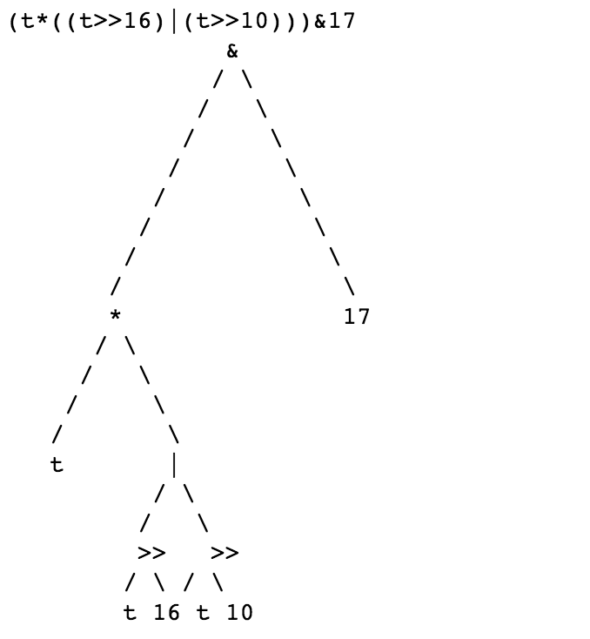 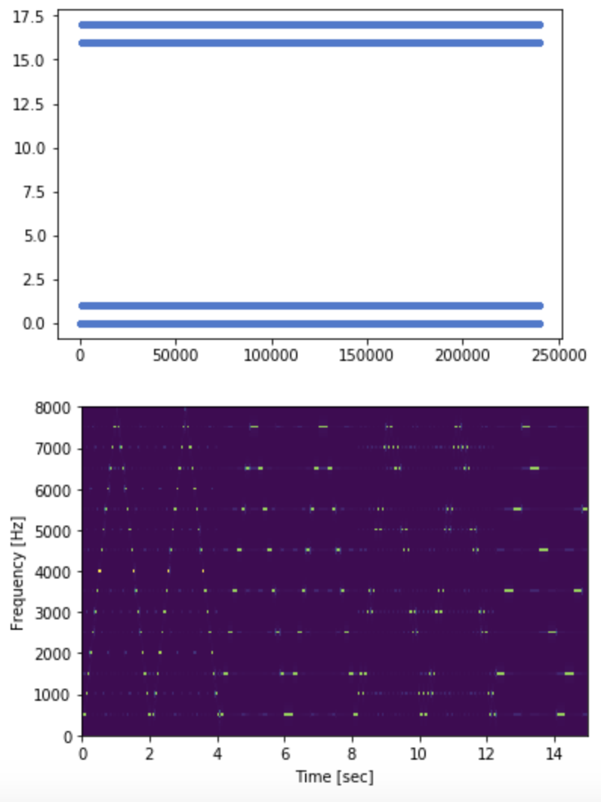

**CHILD (MUTATION)**

